The Scene-First AI Product Photography Guide

WORKFLOW OVERVIEW
The Complete 6-Step Process:
- Deconstruct - Create the Product DNA (analyze geometry, materials, details)
- Analyze Style - Define the rules (as art director, photographer, set designer, brand designer)
- Generate Master Alpha Prompt & Setup Custom GPT - ChatGPT creates your master prompt, then build Custom GPT
- Generate Base Image - Nail the scale and establish the scene (close enough for your product)
- Edit the Images - Use Reeve prompting first, inpainting if needed
- Polish & Upscale - Fix label issues, upscale, improve texture and details

PART 1 — ANATOMY OF A HIGH-CONVERSION PRODUCT PHOTO
A "good" photo is defined by data, not taste. It must answer customer questions visually without friction. If the brain has to work to understand the object, you lose the sale.

1. Material Fidelity (The Psychology of Touch)
The customer can't touch the product, so the image must convey tactile sensation. Materials communicate value, quality, and how the product feels.
Why This Matters:
- Glass: Must show reflection and refraction (light bending through transparent materials) - communicates purity, premium quality
- Metal: Must show specular highlights (bright reflective spots) - communicates durability, craftsmanship
- Fabric: Must show texture, weave, and how it folds - communicates softness, weight, quality
Materials tell a story. Matte finishes feel natural and approachable. Glossy finishes feel technical or luxurious. The AI must render these accurately or the product loses its perceived value.
Lighting's Role:
Lighting reveals material properties. Soft, large light sources show gradients and texture smoothly. Hard light can create drama but may hide important material details or create harsh reflections.

2. Optical Logic (Camera & Lens)
Focal Length Affects Brand Perception:
- 35mm (Wide):
  - Creates perspective distortion, especially at edges
  - Good for environmental shots showing product in context
  - Can make products feel more casual, accessible
  - Not ideal for luxury positioning due to distortion
- 50mm (Standard/Human Eye):
  - Natural perspective, similar to human vision
  - Versatile for both lifestyle and product shots
  - Neutral brand positioning
- 85mm+ (Telephoto):
  - Compresses perspective (flattens the image)
  - Standard for luxury/studio product photography
  - Makes product geometry look accurate and proportional
  - Communicates precision, control, premium positioning
  - The lens choice signals intentional design
Camera Height:
- Eye-Level: Neutral, honest perspective
- Slightly Above (15-30°): The "tabletop" view - shows depth and volume
- Low Angle: Makes products look larger/more impressive
The Point: Lens choice isn't just technical—it's a brand decision. How you frame the product affects how the customer perceives value.

3. The Two Visual Dialects
E-Commerce (Catalog):
- Priority: Information density and clarity
- Technique: Even lighting, everything in sharp focus, pure white or neutral grey background
- Goal: Customer can clearly see what they're buying
Editorial (Brand/Marketing):
- Priority: Aspiration and emotion
- Technique: Selective focus (shallow depth of field), mood lighting, lifestyle props
- Goal: Make customer feel something and desire the product

PART 2 — THE WORKFLOW
This system separates scene generation from product placement. This is how you get consistent results.

STEP 1: DECONSTRUCT (Create the Product DNA)
You must translate your physical product into precise data for the AI.
Analyze Geometry:
Be precise, is it a dropper bottle, is it a screw on cap ? Be specific about what sort of object it is, if you cant find the name just reverse image search or use chatgtp.
Analyze Geometry:
Be mathematical. Is it a cylinder, cuboid, sphere or something else? Specify proportions and scale. How big is it ? How does it fit inside a hand or how tall is it next to a person ? The ai doesn't always understand terms like its 10cm tall sometimes it is easier to describe size and proportion with other known objects
Analyze Material:
"Plastic" is too vague. Use specific descriptions:
- "Matte high-density polyethylene"
- "Translucent amber glass"
- "Brushed anodized aluminum"
Analyze Details:
Cap color, label paper texture (foil vs. matte), liquid viscosity, any text or branding elements.
Analyze Text:
Label text and any other text that is written on the object.
Action: Write your Product DNA Snippet
Example:
You are a senior industrial designer and professional 3D product visualization artist. Analyze the provided product image and describe it using precise, professional design language as if documenting it for a 3D modeling and product development team.

Your description should cover the following:

Overall Product

Explain what the product is, its intended purpose, and its overall design style (e.g., minimalist, rugged, premium, futuristic, clinical, etc.).

Geometry & Form

Describe the primary shapes and proportions. Note symmetry, edge treatments (fillets, chamfers, sharp edges), curvature, surface transitions, and any visible part separations.

Component Breakdown

Identify and describe each major component, including:

Its shape

Its placement

How it connects to other parts

Its likely function

Materials & Finishes

Specify realistic production materials and surface finishes such as matte, gloss, brushed, textured, or soft-touch. Include reflectivity, transparency, and any color blocking.

Surface Details

Describe visible seams, screws, vents, grilles, ports, buttons, logos, textures, overmolds, indicators, lights, and any small functional or decorative elements.

Ergonomics & Interaction

Explain how a user would hold, touch, wear, or operate the product. Mention grip areas, comfort cues, and key interaction points.

Manufacturing Clues

Identify likely manufacturing processes (e.g., injection molding, CNC machining, die-casting), draft angles, mold split lines, and probable assembly logic.

Visible Text

Accurately transcribe all readable text, labels, symbols, and branding visible on the product.

Prompt Snippet Requirement

After the analysis, write a short but dense prompt snippet that includes all key physical details, materials, finishes, form characteristics, and every piece of visible text exactly as shown on the product.
Example:
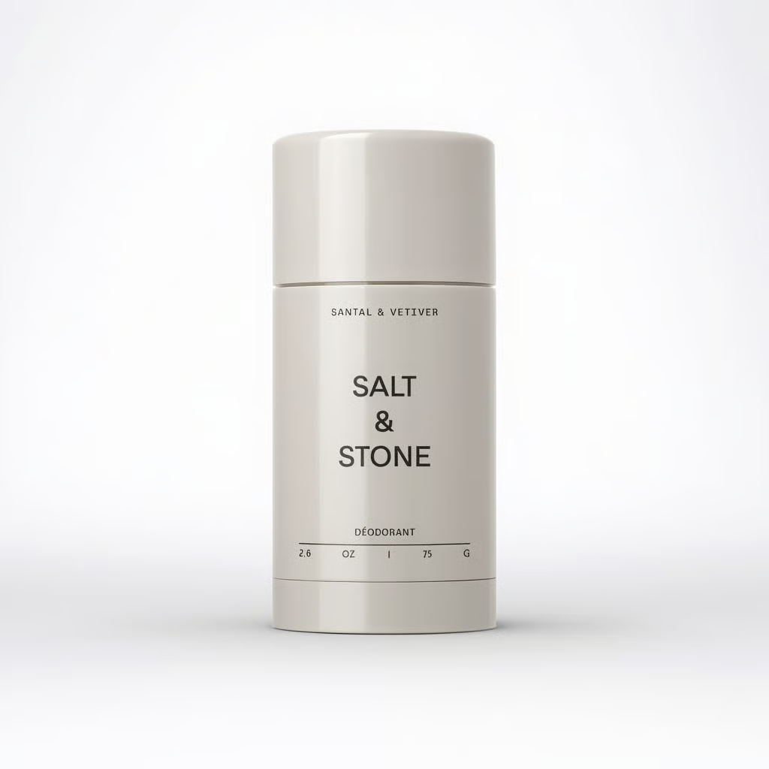
Premium minimalist deodorant stick packaging, vertically oriented cylindrical form with a slightly stout proportion (height ~1.7× diameter), warm off-white matte plastic body with low-sheen satin finish. Softly faceted cylindrical cap with broad vertical planes and rounded filleted edges, flat top with radiused perimeter. Clean horizontal seam slightly above mid-height separating cap from body, plus a second subtle circular seam near the bottom indicating the twist-up mechanism. Smooth sidewalls with gentle draft, no visible fasteners, no grips, no texture breaks. Injection-molded polypropylene or ABS with fine matte mold texture or soft-touch coating. Centered black minimalist typography on front face reading: “SANTAL & VETIVER” (small uppercase at top), “SALT & STONE” (large stacked brand name in bold uppercase), “DÉODORANT” (smaller uppercase below), and bottom line “2.6 OZ / 75 G” separated by a thin horizontal rule. Clean apothecary-inspired branding layout, high-end natural luxury aesthetic, monolithic sculptural presence, tight tolerances, smooth surface transitions, soft edge radii, subtle studio lighting, faint shadow cast to the right on a dark background.
This becomes your reference contract with the AI—used in prompting, not stored in the Custom GPT.

STEP 2: ANALYZE STYLE (Define the Rules)
Think like an art director, photographer, set designer, and brand designer. You're reverse-engineering professional decisions.
What to Analyze:
Light:
- Direction (side, front, back, top)
- Quality (soft/diffused vs. hard/direct)
- Intensity (bright and airy vs. moody and dramatic)
Colors:
- Background tones (hex codes if possible)
- Color temperature (warm vs. cool)
- Accent colors
Grading:
- High contrast or low contrast
- Color saturation level
- Film-like or digital-clean
Framing & Composition:
- Camera angle consistency
- How much negative space
- Product placement (centered, rule of thirds, etc.)
Spacing & Objects:
- Props presence (minimal, styled, none)
- Distance between elements
- Foreground/background relationships
Shapes & Forms:
- Geometric (clean lines, structured) or organic (curves, natural)
- Repetition of shapes in composition
- Surface textures visible in the scene
The Goal: Extract the visual logic that makes your references feel cohesive. This isn't about copying aesthetics—it's about understanding the system behind them.
Analyze your visuals like this:
🎯 MASTER PROMPT: Visual Direction Reverse-Engineering

Role:
You are an art director, photographer, set designer, and brand designer analyzing visual references. Your job is to reverse-engineer the professional decisions behind the images.

This is not about describing what you see casually — this is a design systems breakdown. Think in terms of intentional choices, repeatable patterns, and visual logic.

Your goal is to extract the underlying system that makes the visuals feel cohesive.

🧠 CORE MINDSET

Analyze these images like a creative lead preparing a shoot or brand system.
Identify patterns, not one-off details.

For every category:

Describe what is consistently happening

Explain how it affects the mood or brand feel

Infer why a professional might have made this choice

💡 WHAT TO ANALYZE
1️⃣ LIGHT

Break down lighting with precision:

Direction

Is light coming from the side, front, back, above, or mixed?

Is the direction consistent across images?

Quality

Soft and diffused (window light, bounce, overcast)?

Hard and direct (sharp shadows, specular highlights)?

Intensity

Bright and airy?

Balanced and natural?

Low key, moody, dramatic?

Output Insight:
Explain how the lighting contributes to brand mood (luxury, clinical, cozy, editorial, bold, etc.)

2️⃣ COLORS

Background Tones

Identify dominant background colors

Estimate hex codes when possible

Are backgrounds flat, gradient, textured, or environmental?

Color Temperature

Warm (yellow/orange bias)?

Cool (blue/neutral bias)?

True-to-life neutral?

Accent Colors

What colors pop in small areas?

Are accents from props, wardrobe, product, or lighting?

Output Insight:
Describe the color strategy and how it shapes emotional perception.

3️⃣ GRADING & TONAL STYLE

Contrast

High contrast (deep blacks, bright highlights)?

Low contrast (soft tonal transitions, lifted blacks)?

Saturation

Muted/desaturated?

Natural?

Rich and bold?

Look

Film-like (grain, softness, halation, faded tones)?

Digital-clean (crisp, sharp, true blacks/whites)?

Output Insight:
What does the grading communicate about brand positioning (modern, nostalgic, raw, polished)?

4️⃣ FRAMING & COMPOSITION

Camera Angle

Eye level, top-down, low angle, tilted?

Consistent or varied?

Negative Space

Tight and filled?

Airy and spacious?

Where is empty space typically placed?

Product / Subject Placement

Centered?

Rule of thirds?

Floating in space?

Anchored to surfaces?

Output Insight:
Explain the composition system that repeats across images.

5️⃣ SPACING & OBJECT RELATIONSHIPS

Props

None, minimal, or heavily styled?

Functional or decorative?

Distance Between Elements

Tightly grouped?

Spread apart?

Overlapping layers?

Foreground / Background

Flat background?

Layered depth?

Strong separation or blended?

Output Insight:
Describe how spatial decisions affect visual hierarchy and storytelling.

6️⃣ SHAPES, FORMS & TEXTURES

Dominant Shape Language

Geometric (straight lines, grids, symmetry)?

Organic (curves, irregular, natural forms)?

Repetition

Do certain shapes repeat (arches, circles, rectangles)?

Surface Textures

Matte, glossy, grainy, fabric, stone, metal, skin, paper?

Smooth minimalism or tactile richness?

Output Insight:
Explain how shape and texture choices support the brand personality.

🧩 FINAL SYNTHESIS (MOST IMPORTANT)

After analyzing all categories, summarize:

The Visual Logic – What rules seem to guide these visuals?

The Brand Personality – What kind of brand would use this system?

The Creative Formula – If someone wanted to recreate this approach (not copy images), what consistent principles should they follow?

Write this like you’re handing off a creative direction blueprint to a professional team.

STEP 3: GENERATE MASTER ALPHA PROMPT & SETUP CUSTOM GPT
You don't manually write your prompts. Let ChatGPT do the heavy lifting.
The Process:
- In the same chat where you analyzed style, ask ChatGPT:
"Based on the style analysis I just provided, generate a master prompt for AI image generation. This prompt should enforce the lighting, framing, color palette, and composition rules we identified. Format it as a reusable template where I can insert different scene concepts."
ChatGPT outputs your Master Alpha Prompt, something like:
Studio product photography, 85mm lens, soft diffused lighting from left at 45°, warm neutral background (#F5F5DC), low contrast, minimalist composition with 40% negative space, clean geometric forms, commercial and timeless aesthetic, high resolution, professional photography

- Create Custom GPT:
  - Go to ChatGPT → Create Custom GPT
  - Name: "Product Scene Generator" (or whatever you want)
Instructions:
You are a product photography scene generator. When I describe a scene concept or mood, you will output a complete image generation prompt using this master template:[PASTE YOUR MASTER ALPHA PROMPT HERE]Add the user's scene concept naturally into this template. Keep all the fixed rules (lighting, lens, composition) the same. Only vary the scene elements as requested.Output format: Complete prompt ready to copy-paste into image generator.

- Usage: Now you just tell your Custom GPT: "Ocean mist background" or "Surrounded by fresh herbs" and it outputs the complete prompt with your locked visual system + the scene variation + where you manually add your product snippet.

STEP 4: GENERATE BASE IMAGE (Establish the Scene)
Use Midjourney v6, Flux, DALL-E 3, or your preferred AI image generator.
Goal:
You're trying to nail the scale and establish the scene. It doesn't have to be perfect—just close enough for your product to fit naturally.
What You're Establishing:
- Correct scale - product should occupy roughly the right percentage of frame
- Good enough lighting - direction and quality should match your style rules
- Scene foundation - background, mood, composition roughly match your vision
The Check:
- Is the product the right size in frame?
- Does the lighting direction and softness feel right?
- Does the overall scene match your brand vibe?
If yes, this is your Base Image. You'll refine the product details in the next step.
Prompt Structure:
[Output from Custom GPT] + [Your Product DNA Snippet]

STEP 5: EDIT THE IMAGES (Reeve or Inpainting)
Now you swap or refine the product while preserving your established scene.
Approach:
Option 1: Reeve Prompting (Start Here)
- Load your Base Image into Reeve
- Use natural language prompts to refine the product
- Example: "Replace bottle with [Product DNA Snippet]. Keep lighting and background identical."
- This is usually easier and faster
Replace the product in photo one with the product in photo two
Option 2: Inpainting (If Prompting Doesn't Work)
- Mask/select the specific area to change
- Paste your Product DNA Snippet
- The AI only regenerates the masked area
- Preserves the scene structure more precisely
Replace the product with the product
What This Maintains:
- Camera angle and scale
- Lighting direction and quality
- Background and props
- Overall scene composition

STEP 6: POLISH & UPSCALE
Final refinements to make the image production-ready.
Fix Label Issues:
- Use Nano Banana Pro or your editor's text correction
- "Sharpen the text on label"
- "Fix the logo to be crisp and clear"
- "Correct any text distortions"
Upscale the Image:
- Use upscaling with low creativity/hallucination settings (10-20%)
- This increases resolution while maintaining your established look
- Typically 2x or 4x upscale
Improve the texture and details of this scene keep the scene the same just add subtle details and keep colors and light the same.
Improve Texture and Details:
- Add realistic micro-textures if needed
- "Add subtle paper texture to label"
- "Enhance glass surface detail"
- "Add fine grain for photorealistic finish"
Settings: Keep creativity/strength LOW during upscaling—you want detail enhancement, not reinvention.

KEY PRINCIPLES
Separation of Concerns:
- Scene = lighting, mood, background (established once)
- Product = specific details (swapped or refined)
Lock the Variables:
- Master prompt locks: camera, lighting, composition
- Custom GPT enforces consistency
- Product DNA ensures accurate rendering
Work in Layers:
- Base Image = get scale and scene right
- Editing = refine product specifics
- Polish = final professional touches
The Goal:
Build a system where you can generate dozens of product images that all feel like they came from the same professional photo shoot—because they're following the same visual rules.

WORKFLOW SUMMARY
- Deconstruct: Create detailed Product DNA snippet
- Analyze Style: Think like art director—extract light, colors, framing, composition, spacing, forms
- Generate Master Prompt & Custom GPT: ChatGPT creates your master prompt → build Custom GPT that outputs scene variations
- Generate Base Image: Nail scale and establish scene (doesn't have to be perfect)
- Edit Images: Reeve prompting first, inpainting if needed
- Polish & Upscale: Fix labels, upscale, improve texture/details
The Core Principle:
Separate scene from product. Lock the scene rules. Swap the products. This is how you achieve consistency at scale.

